1. Try using the put command to have this file be moved from local linux system to the hdfs system to a specific target directory /data/books

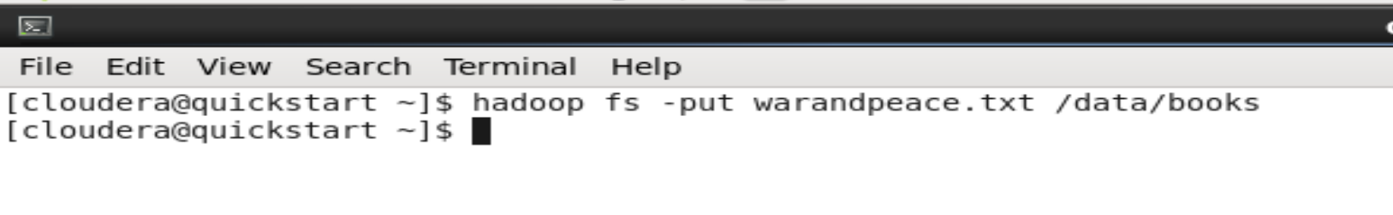

1. Try displaying the contents of this directory where the file was ‘put’



1. Viewing it in the browser

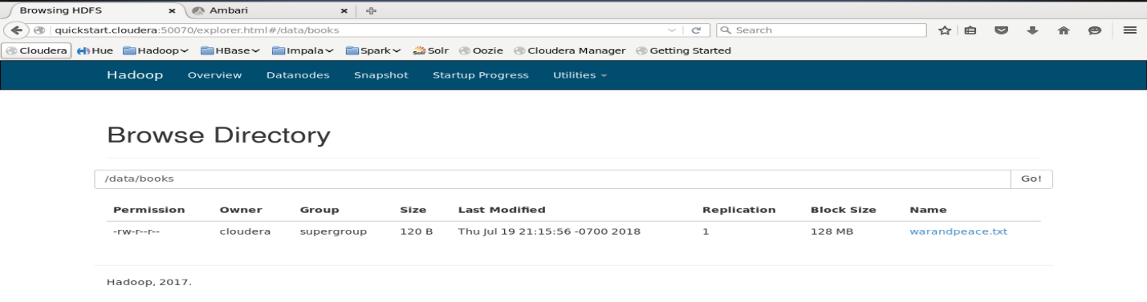

1. Removing the file from the filesystem



1. Now moving the same file from linux to HDFS but now using a different command called CopyFromLocal



Notice the capital F and capital L in “copyFromLocal” command. Any change in this will lead to unknown command error.

1. Again verifying the contentes of the folder (Remember that in step 5 we removed that folder)



1. Again viewing it in the web browser shows that the file is in the folder

